File Permission Task

Step 1: Create a file with .txt extension
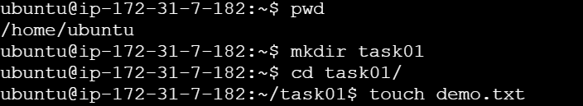
Once the file is created list the file including file permissions using “ls -la” command
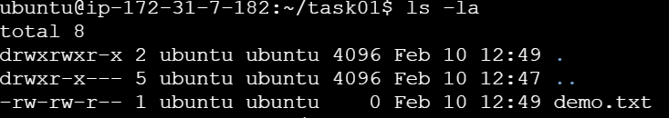
From the above screenshot we can see that default permissions were set to the file.
Step 2: Now we will set the permissions of the file so that any user can read it, group can read/write & owner can read/write/execute using “chmod 764 demo.txt” command as below:
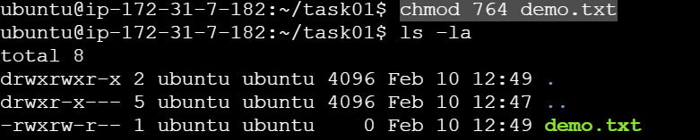
Now lets see the Permission breakdown:
We have set the permission with a numeric value
r (read) = 4
w (write) = 2
x (execute) = 1
- (no permission)=0
We have added these values together to define the total permission for each category.
- Owner (7): r (4) + w (2) + x (1) = 7 (read, write, execute)
- Group (6): r (4) + w (2) + - (0) = 6 (read, Write)
- Any User (4): r (4) + - (0) + - (0) = 4 (read)

